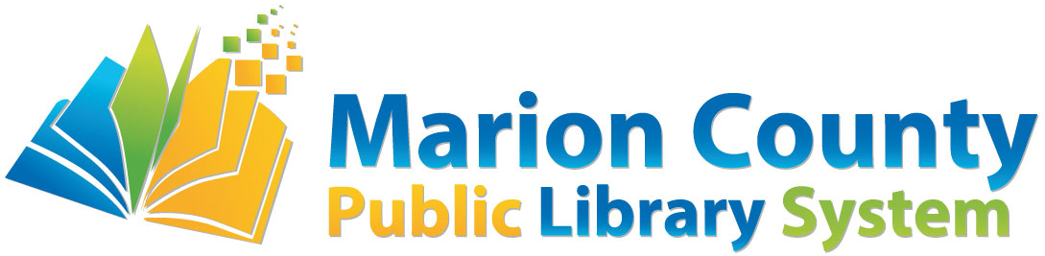

Help Us Decorate Our T(w)een Space!
Seeking creative Tweens and Teens!
We are looking for creative teenagers! We have several 24” x 24” square stretched canvasses and we want you to create art on them! You can do anything that you want with the canvas, as long as we will be able to hang it on the wall and it is appropriate for all ages. There is a box on the back of this page for you to sketch or draw a draft of the art piece you would create if chosen. Include details like what tools and materials you might use or any other notes you want us to know on the lines below the box. You can use any mediums that you would like and you could even create a 3D piece. We want to see what you can do!
The deadline to turn in this form is August 31, either in person or via email to LButta@mcpls.org.
If your design is chosen, you will be contacted via your preferred contact method no later than September 10 so that you can come pick up your canvas. Remember, it’s 24 inches square so you’ll need to be able to carry it home or fit it in your vehicle! All art will be hung in the Youth/Teen Room in Fairmont! Some examples of other art done by teens at other libraries can be found on the last pages of this application. This might help spark your imagination for your own piece!
Not everyone who applies will be chosen this time around, but we do hope to offer this project again in the future so that everyone can get a chance to have their talent on display
Name: ______________________________________________________________
Parent’s Name: _______________________________________________________
Phone Number(s): _____________________________________________________
Email Address: ________________________________________________________
Age: __________ Preferred Contact Method: Phone □ or Email □

Notes/Comments: _________________________________________________________ _________________________________________________________________________________________________________________________________________________________________________________________________________________________________________________________________________________________________________________________________________________________________________________________________
All art below was submitted to the Central Rappahannock Library in Fredericksburg, VA and made by teens like you!
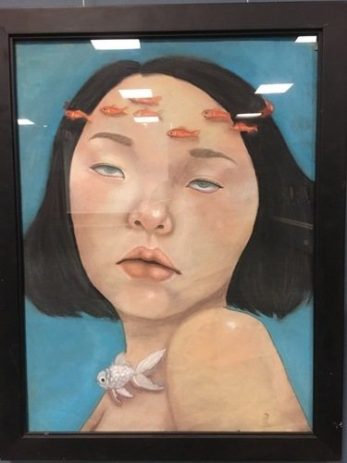 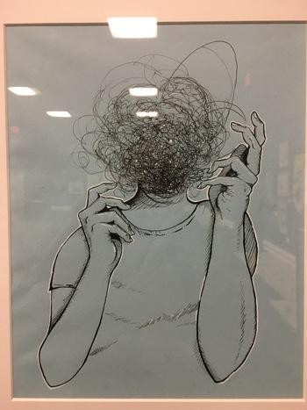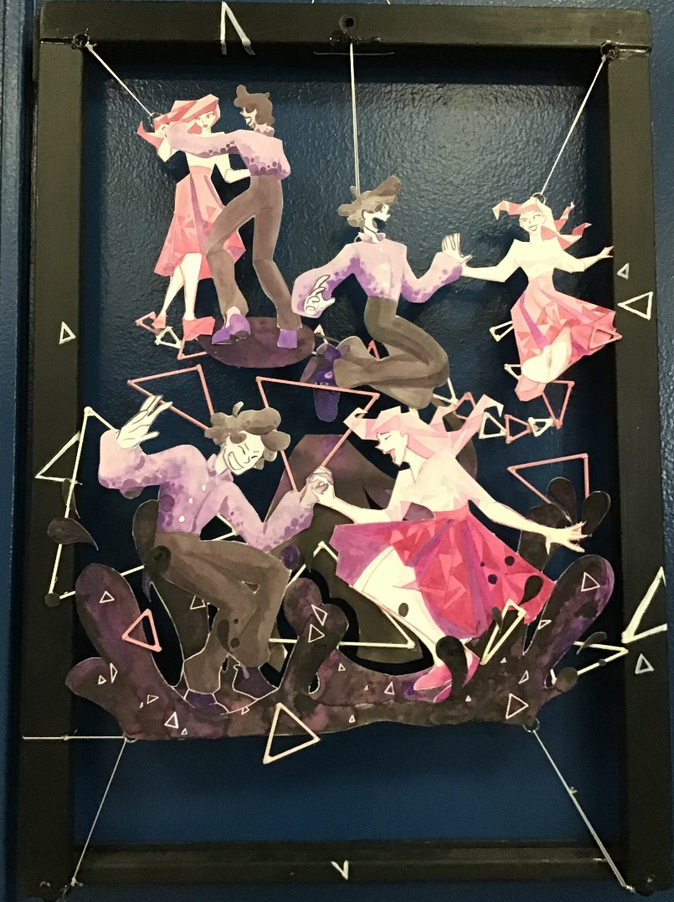 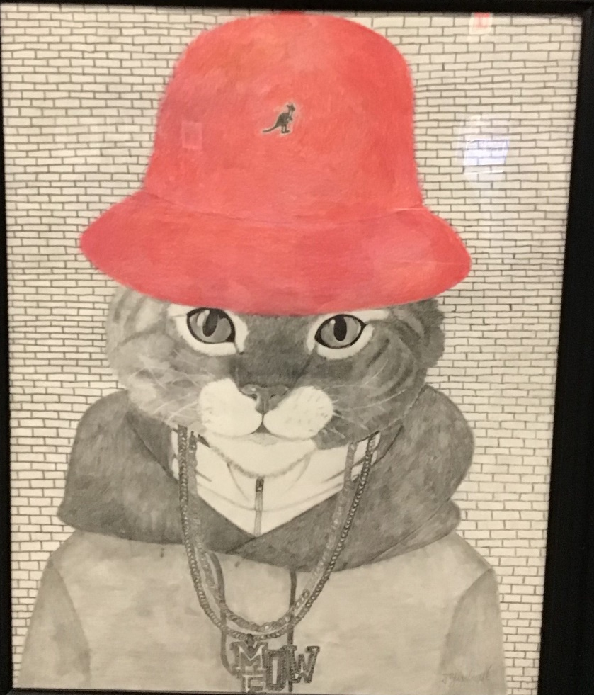 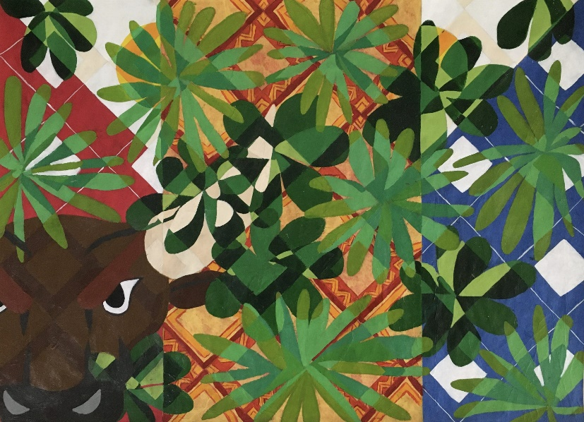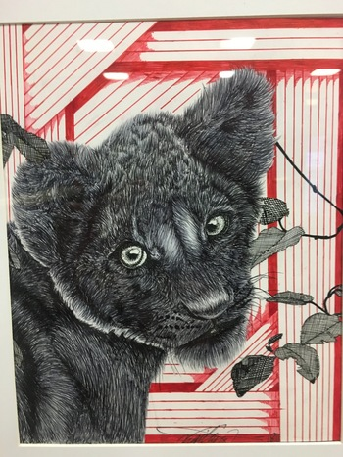 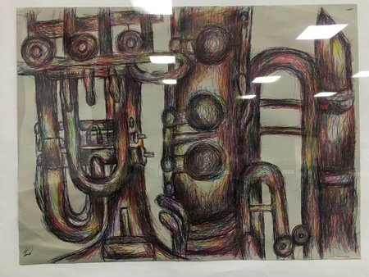 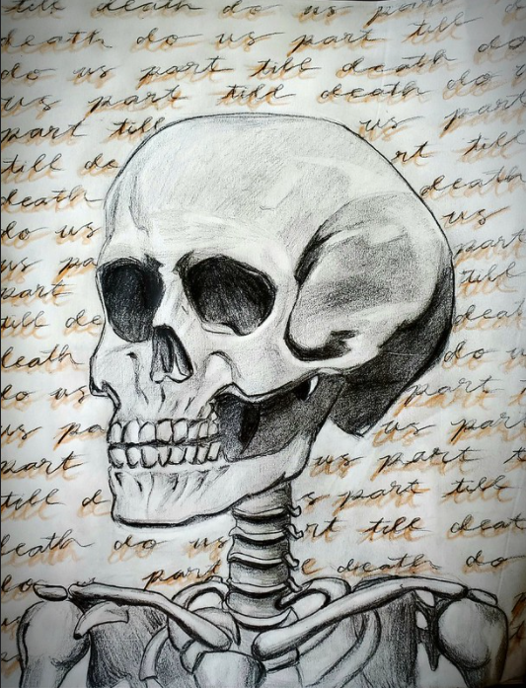
Very True. I think my admin is leaning toward only enforcing a restriction after school hours. We are a very small library and are often short on space unfortunately

Not as far as I have been able to tell s far. We have games for passive programming and they like to use them too, which is fine. I just worry because we already have a super small teen population and I don't want them to be pushed out

