**LIBRARY GUIDE:**

**FINDING A JOB/CAREER**

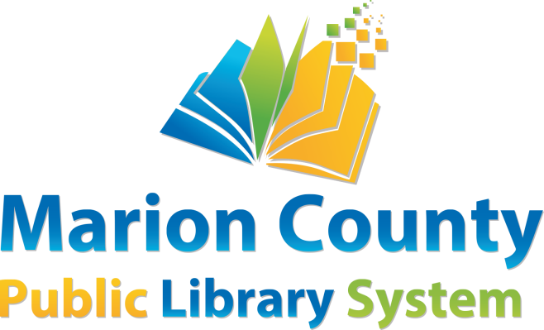

This library guide is designed to help library patrons find information about **Finding a Job/Career** and tools to help patrons find a job. The materials will be found in the Marion County Public Library System or on the World Wide Web.

**BOOKS**

|  |  |  |  |
| --- | --- | --- | --- |
| **MCPL** | Collins, Corbin | *Skilled Trade Professionals: A Practical Career Guide* | 650.14 Col |
| **MCPL** | Enelow, Wendy S. | *Cover Letter Magic: Trade Secrets of Professional Resume Writers* | 650.14 WHI |
| **MCPL** | Grensing-Pophal, Lin | *The Everything Resume Book: From Using Social Media to Choosing the Right Keywords, All You Need to Have a Resume That Stands Out From the Crowd!* | 650.14 GRE |
| **MCPL** | Liptak, John L. | *Career Quizzes: 12 Tests To Help You Discover And DevelopYour Dream Career* | 153.94 Lip |
| **MCPL** | Muchnick, Justin Ross | *Peterson’s Teens’ Guide To College And Career Planning: Your High School Roadmap To College And Career Success* | 371.113 Muc |
| **MCPL** | Panetta, Karen | *Count Girls In: Empowering Girls To Combine Any Interests With STEM To Open Up A World Of Opportunity* | 507.1  Pan |
| **MCPL** | Ryan, Daniel J. | *Job Search Handbook for People with Disabilities* | 650.14 RYA |
| **MCPL** |  | *Green Jobs For A New Economy* | 650.14 Sch |
| **MCPL** | Troutman, Kathryn | *Federal Resume Guidebook: Federal Resume Writing Featuring The Outline Format Federal Resume* | 650.14 Tro |

**eBOOKS & eAUDIOBOOKS**

|  |  |  |  |
| --- | --- | --- | --- |
| **HOOPLA** | Berge, Gregory | *How To Find Your Soul Job* | eBook |
| **HOOPLA** | Beshara, Tony | *101 Small Rules for a Big Job Search* | eBook |
|  |  |  |  |
| **Libby** | Block, Jay A. | *101 Best Ways to Land a Job in Troubled Times* | eBook |
| **HOOPLA** | Carlson, Richard | *The Don't Sweat Guide to Your Job Search* | eAudiobook |
|  |  |  |  |
| **HOOPLA** | Dalton, Steve | *The 2-Hour Job Search* | eAudiobook |
| **Libby** | Farr, Mike | *100 Fastest Growing Careers: Your Complete Guide Book To Major Jobs With The Most Growth And Openings* | eBook |
| **HOOPLA** | Hill, Paul | *The Panic Free Job Search* | eBook |
| **Libby** | Mackay, Harvey | *Use Your Head to Get Your Foot in the Door: Job Search Secrets No One Else Will Tell You* | eAudiobook |
| **Libby** | MacDougall, Debra Angel | *The 6 Reasons You'll Get the Job: What Employers Look for—Whether They Know It or Not* | eBook |
| **HOOPLA** | McKay, Dawn Rosenberg | *The Everything Get-a-Job Book* | eAudiobook |
| **HOOPLA** | Kelley, Katie | *Career Courage* | eBook |
| **Libby** | Wagele, Elizabeth | *The Career Within You: How To Find The Perfect Job For Your Personality* | eBook |
| **HOOPLA** | Zichy, Shoya | *Career Match* | eBook/eAudiobook |

**LIBRARY DATABASES**

The library has four databases that are available to assist you. All of them can be accessed from library computer workstations or remote sites at [www.mcpls.org](http://www.mcpls.org).

* *Job and Career Accelerator*. Explore over 1,000 occupations and match those that fit your interests, search available jobs from over 5 million postings, create professional resumes and cover letters, master interviewing skills, get tips on how to improve your search each step of the way, and organize and track your job search progress. Accessed from the Marion County Public Library website at <http://www.mcpls.org>.

1. Click on **Resources**
2. Click on **Education & Information**
3. From the **Job Assistance** section, select **Job and Career Accelerator**
4. You must create an account with a user name and password to use this database.

Last accessed March 19, 2025.

* *Learning Express Library*. Learning Express Library has practice tests and preparation tips for many common exams such as the SAT, ACT, ASVAB, graduate school admissions, occupational licenses, and elementary school through college practice tests for math, reading and language arts.  Also included are tutorials and e-books on workplace skills improvement and computer and internet basics. Access from the Marion County Public Library website at <http://www.mcpls.org>.

1. Click on **Resources**
2. Click on **Education & Information**
3. From the **Arts & Learning** section, select **Learning Express Library**
4. You must create an account with a user name and password to use this database.

Last accessed March 19, 2025.

**WEBSITES**

* **www.indeed.com**: Indeed aggregates other job search websites for easy searching. Last accessed July 13, 2023.
* **www.linkedin.com:** Business-oriented social networking service that has a good job search section, especially for professionals looking for salaried or contract work. Last accessed March 19, 2025.
* **www.workforcewv.org/:**  The State of West Virginia’s website for unemployed workers, which includes job listings and resources for job seekers. Last accessed March 19, 2025.
* **www.governmentjobs.com:** Job listings for the State of West Virginia. Last accessed March 19, 2025.
* **www.fairmontstate.edu/adminfiscalaffairs/human-resources/job-opportunities:** Job listings for Fairmont State University. Last accessed March 19, 2025.
* **wvumedicine.org/careers/:** WVU Medicine job listings, including United Health Center. Last accessed March 19, 2025.
* ***Occupational Outlook Handbook*,** a publication of the US Bureau of Labor Statistics, tells you the training needed, earnings, expected job prospects, what workers do on the job, and working conditions for hundreds of different types of jobs. Also available on the site are job search tips and information about the job market in each state. Last accessed March 19, 2025. <http://www.bls.gov/OOH>
* ***CareerOneStop*.** This site provides resources for career exploration, training, and jobs. It is sponsored by the U.S. Department of Labor. Last accessed March 19, 2025. <http://www.careeronestop.org/>

**LOCAL COMMUNITY RESOURCES**

* Manpower Phone Number: 304-842-5419

Website: www.manpower.com

Manpower is an employment staffing agency that can assist in finding jobs based on experience, etc.

* Workforce West Virginia Phone Number: 1-800-252-JOBS (5627)

Address: 416 Adams St. Suite 220

Fairmont, WV 26554

Assists individuals with finding both jobs and training/education.