**LIBRARY GUIDE:**

**ALCOHOLISM & RECOVERY**

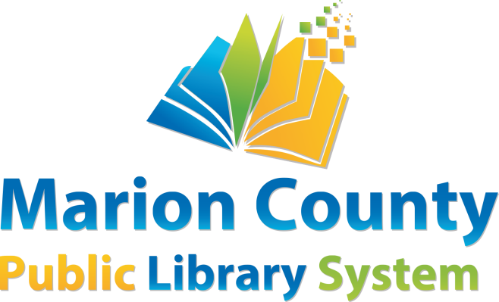

This library guide is designed to help library users find information about **Alcoholism & Recovery**. All material will be found in the Marion County Public Library system or on the World Wide Web.

**BOOKS**

|  |  |  |  |  |
| --- | --- | --- | --- | --- |
| **MCPL** | Conyers, Beverly | *Addict in the family: support through loss, hope, and recovery* | Non-Fiction | 362.292 CON |
| **MCPL** | Grant, Jon E. | *Why Can't I Stop? A Guide for Patient and Families* | Non-Fiction | 616.85 GRA |
| **MCPL** | Husk, Mark A. | *Not So Common Sense: A Little Book of Reminders for Those in Early Recovery* | Non-Fiction | WV 362.292 HUS |
| **MCPL** | Steinberg, Neil | *Drunkard: a hard-drinking life* | Non-Fiction | 616.861 STE |
| **MCPL** | White, Amanda | *Not drinking tonight: a guide to creating a sober life you love* | Non-Fiction | 362.29 WHI |
| **MCPL** |  | *Alcoholics Anonymous: The Story of How Many Thousands of Men and Women Have Recovered from Alcoholism* | Non-Fiction | 362.292 ALC |
| **MCPL** |  | *Paths to Recovery: Al-Anon's Steps, Traditions, and Concepts* | Non-Fiction | 362.292 PAT |

**eBOOKS & eAUDIOBOOKS**

|  |  |  |  |
| --- | --- | --- | --- |
| **HOOPLA** | Cramner, Steven | *The Alcohol Addiction Cure* | eBook |
| **HOOPLA** | Lake, Evelyn Cortel | *Overcoming Alcohol Addiction: The Fail-Proof Pathway To Freedom And Happiness In Life* | eAudiobook |
| **HOOPLA** | McCoy, Jason | *Alcoholics Anonymous-Big Book* | eAudiobook |
| **HOOPLA** | Meyer, Terry Teague | *I Have an Alcoholic Parent, Now What?* | eBook |
| **Libby** | Mooney, A. J. | *The Recovery Book* | eBook |  |
| **Libby** | Peele, Stanton | *7 Tools to Beat Addiction* | eBook |
| **Libby** | Rosen, Tommy | *Recovery 2.0* | eBook |
| **Libby** | Urschel, Harold | *Healing the Addicted Brain: The Revolutionary, Science-Based Alcoholism and Addition Recovery Program* | eBook |
| **Libby** |  | *Get Smart About Alcohol: A Hazelden Quick Guide* | eBook |
| **Libby** | Rogers, Barb | *12 Steps That Can Save Your Life: Real Life Stories from People Who Are Walking the Walk* | eBook |
| **Libby** | Carnes, Patrick J. | *A Gentle Path Through the Twelve Steps: The Classic Guide for All People in the Process of Recovery* | eBook |

**LIBRARY DATABASES**

* ***Consumer Health Complete***supports the information needs of patients and fosters an overall understanding of health-related topics. To access from the Marion County Public Library website, (<http://mcpls.org/)>

1. Hover over **Resources** from the site menu.
2. Click on **Education & Information** from the dropdown menu.
3. Scroll down to the subject heading **Consumer Help**, and select **Consumer Health Complete** from the list of databases.
4. Enter the search term in the Find box.

A search for “alcoholism” brought over 22,000 hits. Last accessed March 13, 2025.

* **EBSCOhost Web Databases.** *Alt Healthwatch*, which focuses on complementary, holistic and integrated approaches to healthcare and wellness, and *Health Source Consumer Edition*, a consumer health information database, offer magazine articles, book excerpts and periodicals on a variety of medical issues. To access from the Marion County Public Library website, (<http://mcpls.org/)>

1. Hover over **Resources** from the site menu
2. Click on **Education & Information**  from the dropdown menu
3. Scroll down to the subject heading **General Reference Searching**, and select **EBSCO Research Databases**.
4. Select the databases you wish to search or click the **Select/Deselect all** box once to search all available databases and click Continue.
5. Enter the search item in the search box.

A search for “alcoholism treatment” brought over 35,000 hits. Last accessed March 13, 2025.

**WEBSITES**

* **National Institute on Alcohol Abuse and Alcoholism (“NIAAA”)**: NIAAA is part of the National Institutes of Health. It “leads the national effort to reduce alcohol-related problems” by promoting research and collaborating with agencies engaged in alcohol-related work. Its website contains information suitable for everyone (not just researchers) about alcohol and health, including alcohol’s effects on the body, fetal alcohol syndrome, and support and treatment. Last accessed March 13, 2025.

<http://www.niaaa.nih.gov/>

* **The National Institute on Drug Abuse (“NIDA”):**NIDA’s “mission is to advance science on the causes and consequences of drug use and addiction and to apply that knowledge to improve individual and public health.” The site offers information, articles, videos, and statistics for not only researchers and medical and health professionals, but also for patients and families, and parents and educators. There is specific information about alcohol addiction. Last accessed March 13, 2025.

<https://www.drugabuse.gov/>

* **Alcoholics Anonymous.** This site has video and audio resources, links to locate a meeting site, daily reflections and an online bookstore. Last accessed March 13, 2025.

<https://www.aa.org>

**LOCAL COMMUNITY RESOURCES**

* Alcoholics Anonymous Area 73 Phone Number: 24/7 hotline 800-333-5051

Local Number: 304-291-7918

Website: https://www.aawv.org/

**About Resource:** AA is a free program where individuals who have alcohol addiction come together to solve their drinking problem. There is no age or educational limits.

* Al-Anon/Alateen Phone Number: 888-425-2666

Address: 329 Maryland Ave.

Fairmont, WV 26554

Website: https://al-anon.org/

**About Resource:** Al-Anon and Alateen is family support groups for anyone affected by a relative or friend’s drinking: this is the only requirement to be a part of a meeting. The program is self-supporting, apolitical, and welcomes all cultures. Local meetings are at 11 AM at the Immaculate Conception Church at address listed.