**LIBRARY GUIDE:**

**ADDICTION**

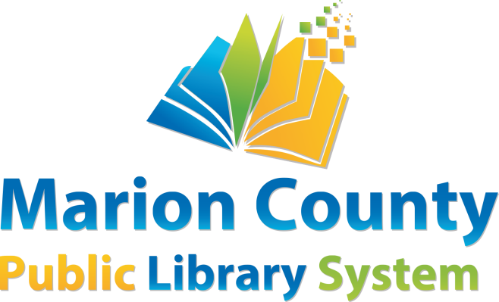

This library guide is designed to help library users find information about **Addiction**. The materials will be found in the Marion County Public Library system, or on the World Wide Web.

**BOOKS**

|  |  |  |  |  |
| --- | --- | --- | --- | --- |
| **MCPL** | Alter, Adam L | *Irresistible: The Rise of Addicitve Technology and the Business of Keeping Us Hooked* | Non-Fiction | 302.23 ALT |
| **MCPL** | Cooper, Grant | *Never Smoke Again: The Top 10 Ways to Stop Smoking Now and Forever* | Non-Fiction | 616.86 COO |
| **MCPL** | Fraser, Liz | *Coming clean: a true story of love, addiction and recovery* | Non-Fiction | 92 FRA |
| **MCPL** | Green, Kelly E. | *Relationships in recovery: repairing damage and building healthy connections while overcoming addiction* | Non-Fiction | 362.29 GRE |
| **MCPL** | Greysheeters Anonymous | *Twelve Steps and Twelve Traditions of Greysheeters Anonymous* | Non-Fiction | 613.2 GRE |
| **MCPL** | Sheff, David | *Beautiful Boy: A Father’s Journey Through his Son’s Addiction* | Non-Fiction | 362.29 SHE |
| **Mannington** | Sheff, David | *Clean: Overcoming Addiction and Ending America’s Greatest Tragedy* | Non-Fiction | 362.29 SHE |
| **Mannington** | Sheff, Nic | *Tweak: (Growing Up On Methamphetamines)* | Non-Fiction | 362.29 SHE |
| **Mannington** | Sheff, Nic | *We All Fall Down: Living with Addiction* | Non-Fiction | 92 SHE |
| **MCPL** | Waterston, Ellen | *Then there was no Mountain: The Parallel Odyssey of a Mother and Daughter through* *Addiction* | Non-Fiction | 363.29 WAT |
| **MCPL** |  | *Are Social Networking Sites Harmful* | Non-Fiction | 302.3 KIE |
| **MCPL** |  | *Addiction* | Non-Fiction | 362.29 ADD |
| **MCPL** |  | *Addiction: Opposing Viewpoints* | Teen Non-Fiction | Teen 362.29 ADD |

**eBOOKS & eAUDIOBOOKS**

|  |  |  |  |
| --- | --- | --- | --- |
| **Hoopla** | Schull, Natasha Dow | *Addiction By Design* | eBook |
| **Hoopla** | Seydel, Andrea | *Saving You Is Killing Me: Loving Someone With An Addiction* | eBook |
| **Libby** | Brand, Russell | *Recovery* | eAudiobook |
| **Libby** | Seidman, Daniel F | *Smoke Free in 30 Days* | eAudiobook |
| **Libby** | Anne, Katherine M.A. | *Anatomy of a Food Addiction: The Brain Chemistry of Overeating* | eBook |
| **Libby** | Bordeaux, Patrick | *Escaping Addiction* | eBook |
| **Libby** | Dodes, Lance | *Breaking Addiction A 7 Step Handbook For Ending Any Addiction* | eBook |
| **Libby** | Mohammad, Akikur | *The Anatomy of Addiction* | eBook |

**VIDEOS & eVIDEOS**

|  |  |  |  |
| --- | --- | --- | --- |
| **HOOPLA** | Addicted Teens: Drug Addiction |  | eVideo |
| **MCPL** | Addiction | 611.81 ADD | DVD |
| **MCPL** | Heroin’s Grip | 362.29 HER | DVD |

**LIBRARY DATABASES**

* ***Consumer Health Complete***supports the information needs of patients and fosters an overall understanding of health-related topics.  Accessed from the Marion County Public Library website at <http://www.mcpls.org>.

1. Click on **Resources**
2. Click on **Education & Information**
3. From “**Consumer Help**” section, select **Consumer Health Complete** from the list of databases.
4. Enter the search term in the Find box.

A search for “addiction” brought over 34,000 hits. Last accessed March 12, 2025.

* ***EBSCOhost Web Databases*.** *Alt Healthwatch*, which focuses on complementary, holistic and integrated approaches to healthcare and wellness, and *Health Source Consumer Edition*, a consumer health information database, offer magazine articles, book excerpts and periodicals on a variety of medical issues. Accessed from the Marion County Public Library website at <http://www.mcpls.org>.

1. Click on **Resources**
2. Click on **Education & Information**
3. From “**General Reference Searching**” section, select **EBSCO Research** Databases.
4. Check the databases you wish to search and click Continue.
5. Enter the search term in the Find box.

A search for “addiction” brought over 261,000 hits. Last accessed March 12, 2025.

**WEBSITES**

* ***The National Institute on Drug Abuse (“NIDA”).***NIDA’s “mission is to advance science on the causes and consequences of drug use and addiction and to apply that knowledge to improve individual and public health.” The site offers information, articles, videos, and statistics for not only researchers and medical and health professionals, but also for patients and families, and parents and educators. There is also specific information about addiction and children and teens. Last accessed March 12, 2025.

<https://www.drugabuse.gov/>

**LOCAL COMMUNITY RESOURCES**

* HELP4WV Phone Number: 844-435-7498

Website: help4wv.com

**About Resource:** This organization provides 24/7 help with mental health or substance abuse issues. This organization has access to over 1,000 services. Recently implemented a children's helpline. Go to their website for more information. Also, the hotline number listed can be called or texted, or chat with a live agent on their website.

* United Summit Center Phone Number: 304-623-5666

Website: https://rni.wvumedicine.org/united-summit-center/

**About Resource:** USC coordinates with WVU Medicine to assist with acute and chronic psychiatric disabilities, developmental disabilities, substance abuse problems, and people who are in crisis. They also offer ATU (Adult Transitional Unit) which provide monitoring and care for patients after psychiatric hospitalization. Services provided include, but are not limited to, multi-disciplinary evaluation, medication management, individual, family and group therapy, substance abuse education/counseling, and other support services. Adult Crisis Hotline: 1-800-SUMMIT-0 Child Crisis Hotline: 1-844-985-4371